BGRFC 2023 AGM Minutes
21st June 2023 at 8pm
In Jubilee Room Barns Green Village Hall
Chaired by the President Bill Bailey

- Apologies for absence received from Gemma Underwood, Peter Burdfield, Tizz Burdfield, John O’Kane and Nick Lewis
- To consider and approve the minutes of the previous AGM held on 20th July 2022.
Agreed unanimously
Proposed by Tom Bouet, Seconded by Bill Bailey
- Introduction and report by the President

INTRODUCTION AND REPORT BY THE PRESIDENT
Season 2022/23 has from my point of view as President been a most positive, enjoyable and successful one.
The most striking feature for me has been the amount of people who have stepped up or in and voluntarily worked together to create a succession of improvements to our already unique way of doing things, some of them downright breathtaking and all of them creative and designed to support our playing of the game across several formats.
Thank you to everyone who has been involved in an unrelenting desire to reflect our personality and keep us punching well above our weight. Movember, VP lunch and player food, a tour to Jersey, a trip to London Irish, themed outfits, an increase in quality First Aid support, a bar that arrives pitch-side under its own steam, (and seemingly makes more profit asking for donations than it ever would by charging) a helicopter to deliver man and match ball, some quality coaching, the Si Viney Tag Sevens and most recently a players award supper.
This succession of activity and events has seen us grow membership to over 70 people now and also maintain a high profile in the County. On the field our style of play remains exciting and positive, occasionally flamboyant and the arrival of new players has helped us drop our average age a bit and give every side in our League a game to remember. The cup finale to the season remains a disappointment but our stance was unquestionably correct and matched the values of the game.
The arrival of Walking Rugby and continuation of Touch rugby means we are now providing 3 types of the game in Barns Green.

On handing over the Presidency I would ask us all to maintain a high focus on participation and genuine inclusivity , encouraging our friends to come and join us whilst being true to ourselves.
We must concentrate on building momentum in every possible way

- To receive and approve a report from the Committee Chairman on the affairs of the club since the previous AGM.

CHAIRMAN’S REPORT

The work of the committee over the last year has continued to be aimed at providing the facility for rugby to be played in Barns Green, including contact, non–contact and more recently walking rugby. The recent 2022-23 season has been a great success both on and off the rugby field and I would like to thank the members of the committee and numerous willing volunteers for their hard work and enthusiasm that has helped make this happen.

One of the core activities of the committee is to ensure the prudent use of our hard finances. We continue to be in a good financial position and my thanks goes to Hon Treasurer Alan Lambkin who has worked hard to provided us with up to date monthly clear transparent accounts, that have allowed us to prioritise expenditure and keep our spending in line with his realistic targets.
Another core activity is the provision and maintenance of our playing field and this year the committee have funded further professional work that has resulted in improvements of the playing surface – this continues to be a work in progress. We are as ever grateful to Peter Burdfield for his generosity for the use of the field.

The committee have had the input of player representatives James Dickson and Tom Bouet who have kept us aware of the players’ opinions and suggestions. This has greatly helped the committee in decision making and funding of activities and also with strategies for retention and recruitment. The committee has to respond to numerous directives from the RFU and SRFU regarding both on the field and administrative issues and decide which ones are relevant to a club like ours. I am confident that we are compliant with the current regulations.

Members of the Committee have attended Social Club and Field Committee meetings so that we as a club are able to assist in the planning and execution of the improvements to the old changing rooms. We have also put in place the plans for the Richie Barrett and Alfie Dodgson awards.

We welcome two new members to the committee in Amie Dickson and Mike Mann. Both have already demonstrated their hard work and enthusiasm in willingly volunteering for tasks during the season and we look forward to working with them. We would welcome any other members who feel that they could contribute towards the administration and smooth running of the club and any volunteers to take on named specific tasks.

We look forward to next season and welcoming new and established players , VPs and supporters to the Field of Dreams.
Bruce McLeod
Approved
- To receive a report from the Treasurer and approve the Financial Statements for the preceding financial year together with the Accountants report thereon. 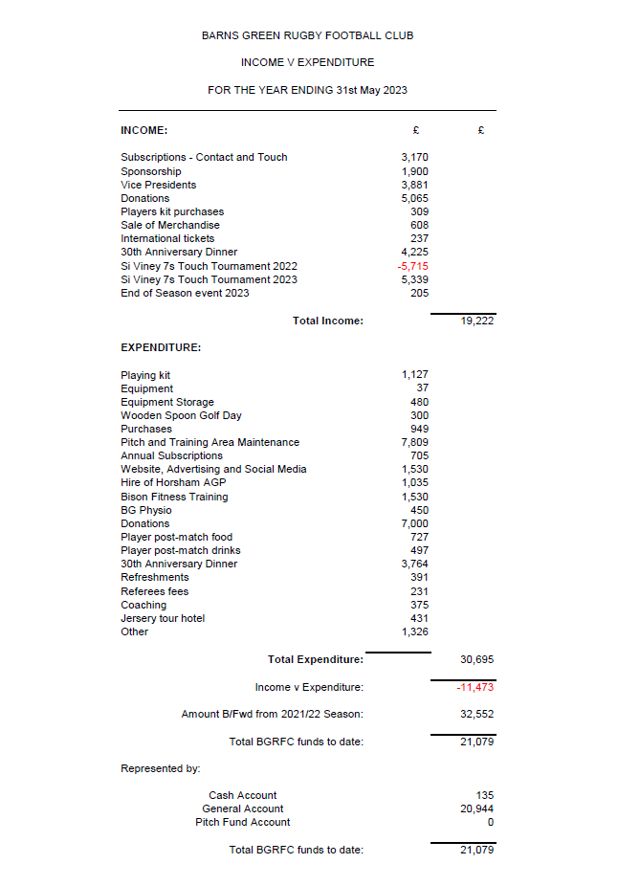
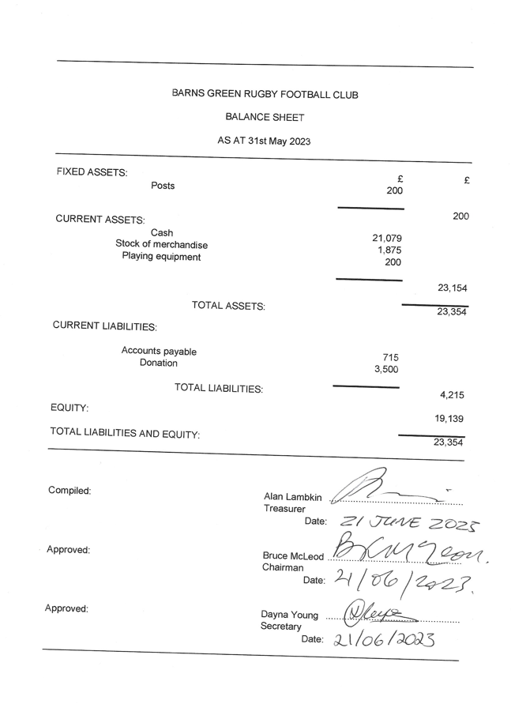
The Financial Report was Unanimously Agreed
- To receive and approve a report from the Team Captain for the 2022/23 season.
CAPTAIN’S REPORT
My first captain’s report !!!!!!!!
I want to start by thanking all the lads for their support, especially Bill, Bouet, George and the rest of the leadership group.

Last season was a steep learning curve for myself personally on and off the field and we couldn’t have got through the season successfully without pulling together as barns green always does .
The lads played their socks off, played with pride and passion which is all I could ask for.
Our goal for the season was to finish in the top half of the league.
After not for filling Hellingly away , our ambition was to for fill every other fixture, which we did just about, and personally make sure Jersey were in our league again, which we can thank Worthing for.
The season started with a scrappy first game against Steyning but we got the win thanks to Stephen for ending the game early .
We got dished our karma with the last game against Jersey unfortunately ending the wrong way with the referee breaking his leg, , taking a potential win and 2nd place finish in the league away, resulting in a loss and a respectable 4th place finish.

I know a lot of people’s favourite game was Horsham. Fantastic performance but I didn’t play that one through injury so it doesn’t count!

My highlight was clearly Jersey.
To travel with the lads across the pond with all the fuss around the weekend, keeping everyone’s heads on, to put together a performance for the travelling fans and come away with a WIN made it even more special for me.

In conclusion it was a successful season and now the hard work starts for next season .
Big recruitment drive this summer, onwards and upwards.
James Dickson
Approved
- To agree Committee recommendations from RFU All Club’s meeting.
Top 3 items for 2023/24 season confirmed as Sponsorship, Coaching and Notice board & Social media
Tom Bouet and James Dickson already looking at these, the club welcomes help from all members to support these.
Agreed

- To Elect the Members of the Committee for the ensuing year.
The Following members were re-elected Alan Lambkin, (Treasurer), Bruce McLeod, Thomas Bouet, Gwilym Jennett, Adrian Lewis, Andrew Stanbridge, and Dayna Young.
Agreed
Andrew Stanbridge to become President of the club
Proposed by Bill Bailey as per last year’s AGM re incumbent responsible for finding new president
Seconded by Alan Lambkin.
Aimee Dickson and Mike Mann were elected to join the committee.
Proposed by Bill Bailey,
Seconded by Gwilyn Jennett and Tom Bouet

The Officers, Alan Lambkin and Bruce McLeod, Dayna Young were re-elected and Andrew Stanbridge was elected as President
Agreed

- To consider a resolution disapplying the provisions of the Act relating to the obligation to appoint Auditors.
Agreed unanimously
- To hear any other relevant matter for the consideration of the Committee during the ensuing year, but on which no voting allowed.
In recognition of their contribution to the Club, The Richie Barrett Endeavour award was awarded to Mike Mann and The Tracy Jennett Honours Cap was awarded to Bill Bailey

The AGM closed at 20:55

